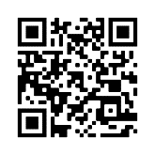

**This baby is in the**

**Trial**

Scan the QR code for more info:

**Please RANDOMISE once a blood transfusion is needed**

IRAS 309894 | WHEAT Trial Cot Cards – Eligibility | V1.0 04OCT2022



**Guidance:**

* **Attach these cards to the cot of an infant eligible for the WHEAT Trial, but not yet randomised as they currently do not require a blood transfusion.**
* **The QR code links to the trial website for further information on the WHEAT Trial.**

**This baby is in the**

**Trial**

Scan the QR code for more info:

**Please RANDOMISE once a blood transfusion is needed**

IRAS 309894 | WHEAT Trial Cot Cards – Eligibility | V1.0 04OCT2022

