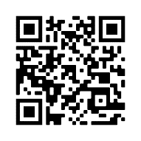

**Guidance:**

**Attach these cards to the cot of an infant randomised to the CONTINUE ARM.**

**The QR code links to the trial website for further information on the WHEAT Trial.**

**This baby is in the**

**Trial**

Scan the QR code for more info:

**Please**

**CONTINUE FEEDS**

**around transfusion**

IRAS 309894 | WHEAT Trial Cot Cards – Continue Arm | V1.0 04OCT2022

**This baby is in the**

**Trial**

Scan the QR code for more info:

**Please**

**CONTINUE FEEDS**

**around transfusion**

IRAS 309894 | WHEAT Trial Cot Cards – Continue Arm | V1.0 04OCT2022